Vietnam PDPD Compliance for Log360
Strengthen data protection and meet Vietnam PDPD compliance with Log360.
Region: Vietnam | Type: Data Privacy | Category: Compliance | Pricing: Free

Overview
The Vietnam PDPD compliance extension in Log360 helps organizations meet Vietnam's Personal Data Protection Decree (Decree 13/2023/ND-CP), Vietnam's comprehensive data privacy regulation effective July 2023 applicable to all entities processing personal data of Vietnamese citizens by providing centralized log management, real-time access monitoring, and automated breach detection. The platform supports Vietnam PDPD requirements for consent management, data security controls, breach detection and notification, data subject rights, impact assessment records, cross-border transfer monitoring, and processor obligations.
For Consent and Lawful Data Processing, Log360 monitors authentication events, MFA activities, and database access logs to provide evidence of authorized processing for Ministry of Public Security audits. To address Data Security and Access Controls, the platform monitors authentication events, privileged account access, and failed logon attempts across all systems processing Vietnamese personal data. The extension also supports Personal Data Breach Detection and Notification by providing capabilities that monitors threat detection events, network attacks, and anomalous access patterns to identify personal data breaches and support timely regulatory notification.

Key Features
- Data Subject Rights Fulfillment: Log360 audits database DDL and DML changes, tracks record modifications, and monitors administrative actions to demonstrate timely fulfillment of personal data rights requests.
- Impact Assessment and Record Keeping: Log360 centralizes audit logs from databases, identity platforms, and operating systems to create comprehensive processing records for compliance review.
- Cross-Border Data Transfer Monitoring: Log360 monitors cloud storage integration events, AWS data transfers, and third-party access logs to track and document cross-border personal data flows.
- Processor and Third-Party Obligations: Log360 monitors cloud service provider activities, vendor access events, and integration logs to track processor compliance and detect unauthorized data handling by third parties.
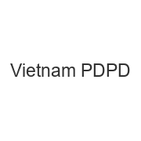

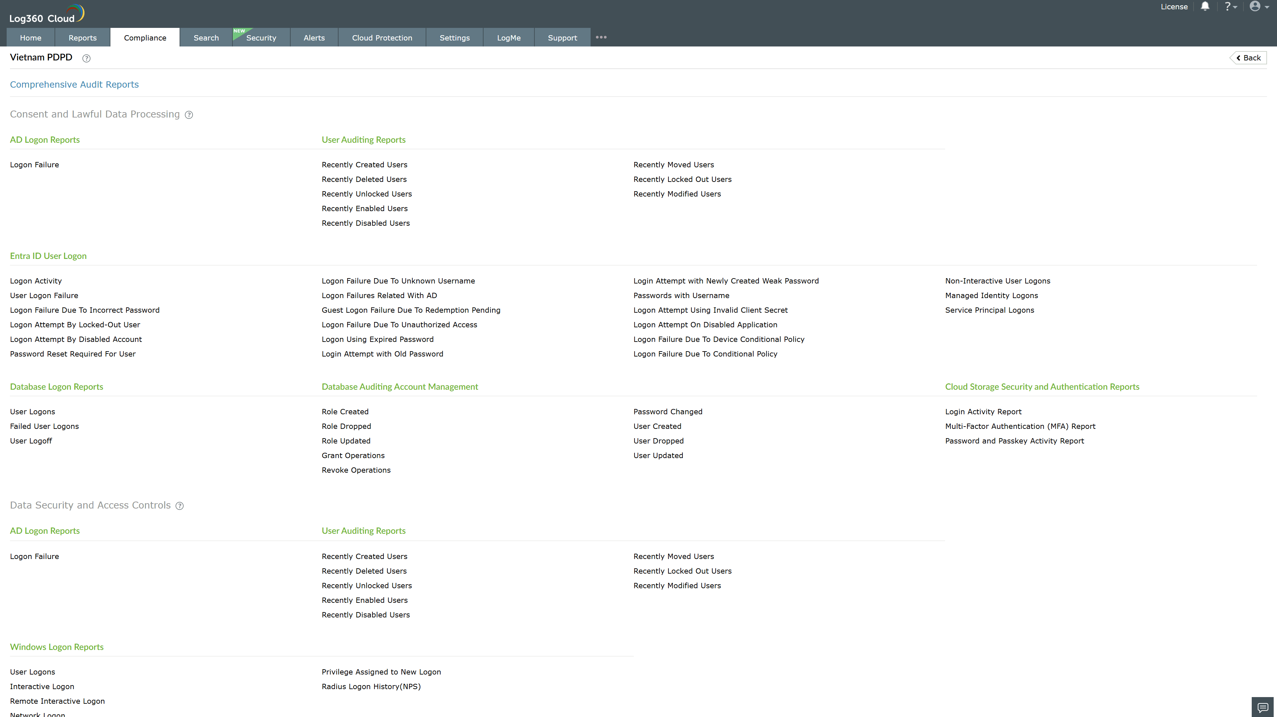
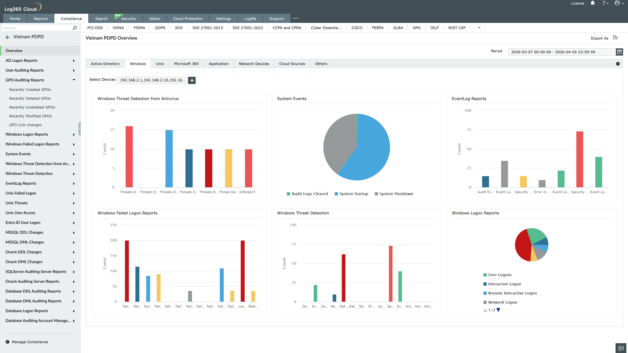
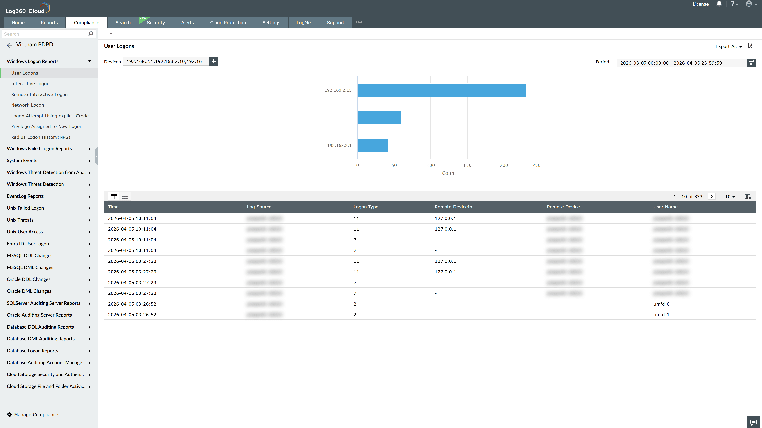
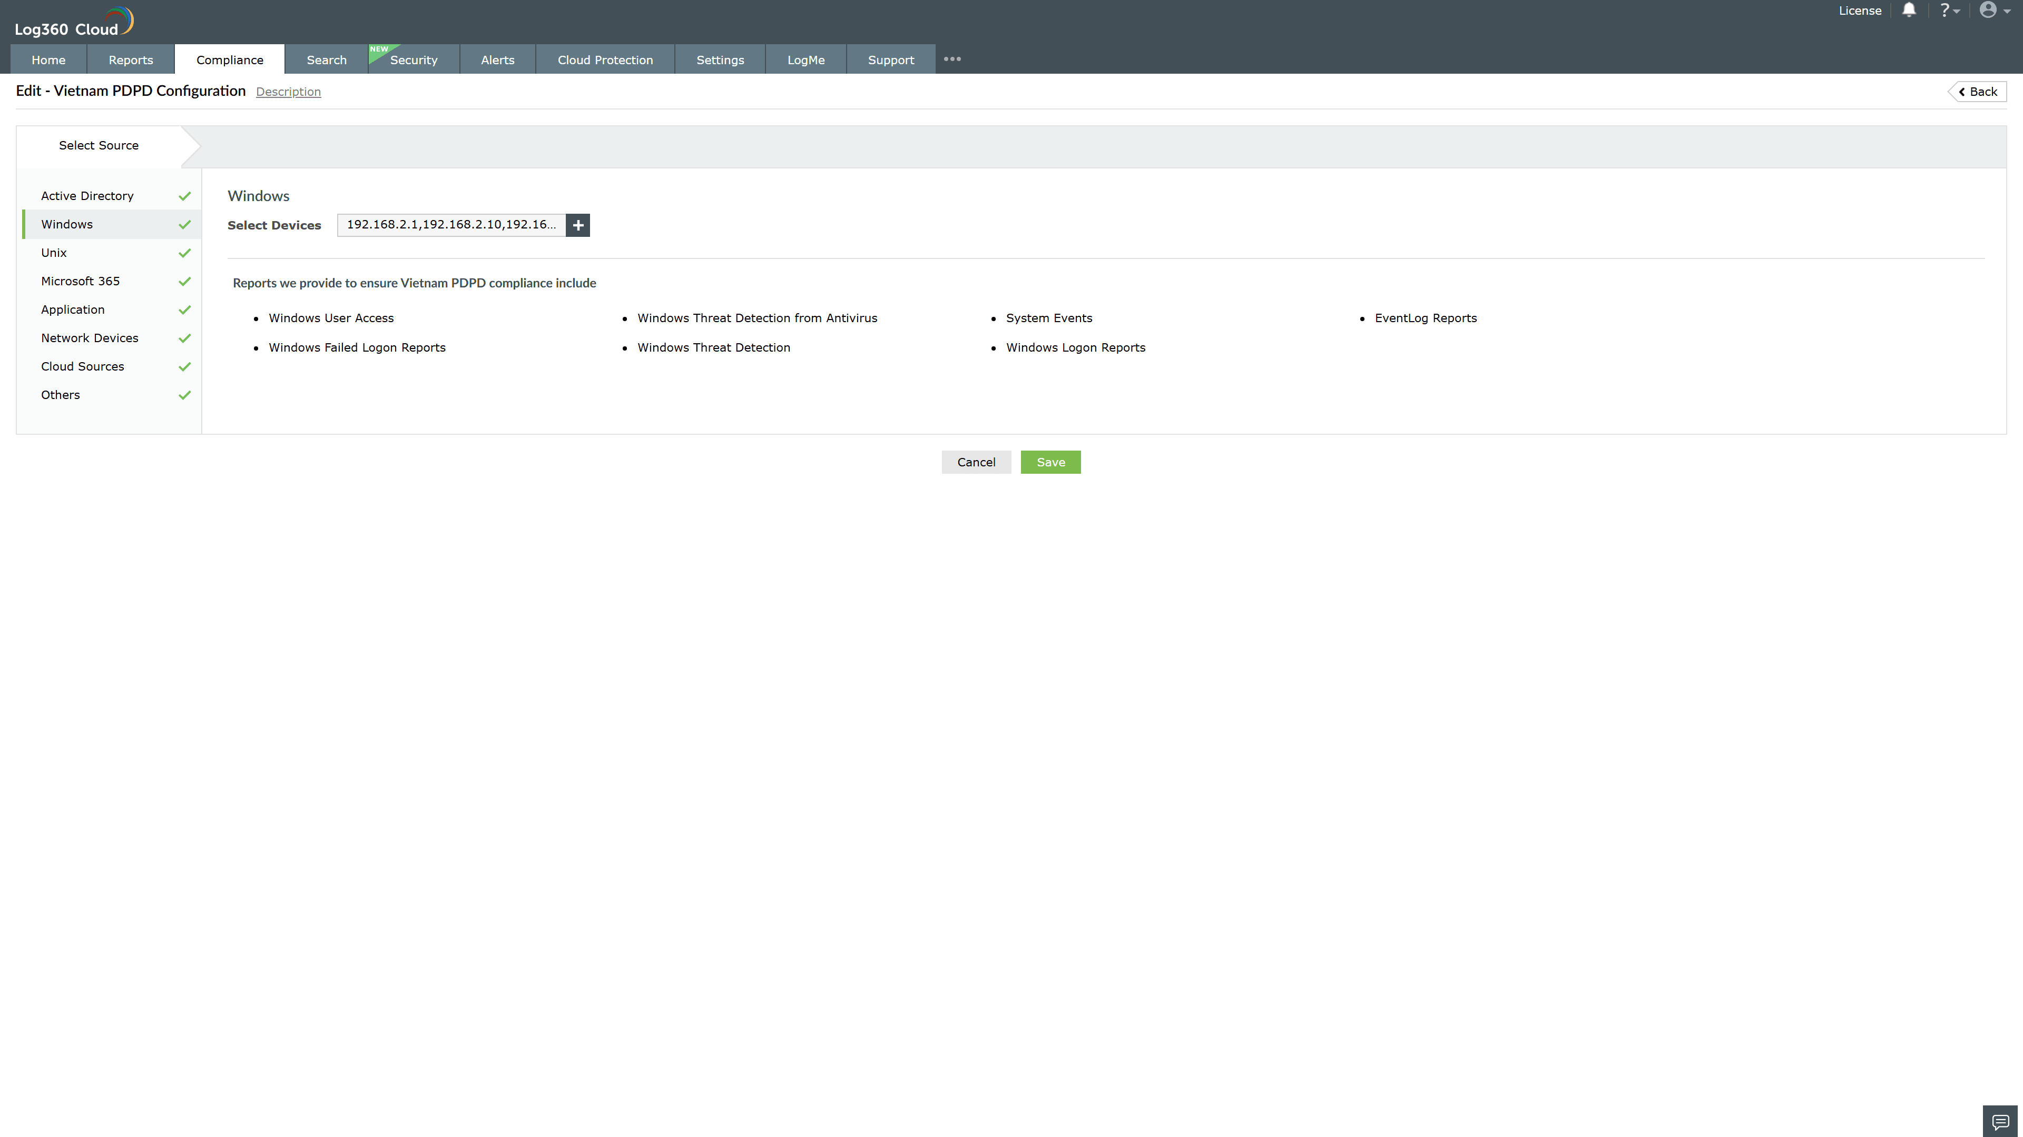
Valid Submission : Yes
Supported Editions : Free, Basic, Standard, Professional, MSSP
Help Document : https://www.manageengine.com/log-management/help/integrations/compliance-extensions.html
Help Video : Not provided
Tags : Log360, Compliance, Privacy monitoring, Data privacy, Regulatory compliance
Supported DCs : US, IN, JP, CA, AU, UK and EU
Privacy Policy:
Terms of Service:
Release Notes:
Predefined reports for the Vietnam PDPD.

